ALK (D1225N)
Catalog Number: CR-M26290
Gene Symbol: ALK, CD246, NBLST3
Description: Anti-ALK (D1225N) Mouse Monoclonal Antibody

Background: Anaplastic lymphoma kinase (ALK) also known as CD246 (cluster of differentiation 246) is a tyrosine kinase receptor that plays an important role in the development of the brain and nervous systems. Deficiencies in ALK, which most commonly as a fusion with other genes, are indicated in cancers. Immunogen: A synthetic peptide from the internal region of ALK which includes the mutation of D1225N, human origin.
Tested applications: ELISA, WB
Recommended dilutions:
ELISA: 1:1000-1:5000
WB: 1:500-1:2000
Concentration: 1 mg/ml
Host: Mouse
Clonality: Monoclonal
Purity: Purified from ascites
Format: Liquid
Storage buffer:
Preservative: no
Constituents: PBS (without Mg²⁺ and Ca²⁺), pH 7.4, 150 mM NaCl, 50% glycerol
Species Reactivity: Recognizes D1225N mutant, but not wild-type ALK of vertebrates.
Storage Conditions: Store at -20°C. Avoid freeze / thaw cycles.

Western blot:
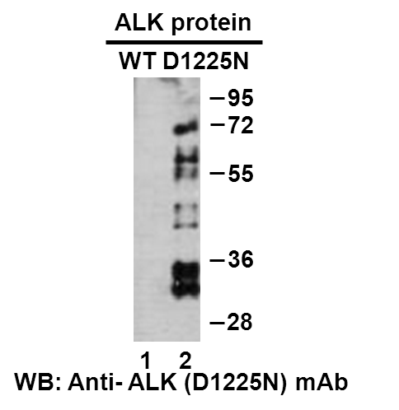
Western blot analysis of recombinant ALK (D1225N) and wildtype proteins. Purified His-tagged ALK (D1225N) protein (1060-1620aa, 68KD, lane 2) and corresponding wildtype protein (lane 1) were blotted with anti-ALK (D1225N) monoclonal antibody (Cat. #26290).

科博瑞（武汉）生物科技有限公司
TEL：027-87615885 15972062685
- mail：3636901710@qq.com
Web:www.coburybio.com

